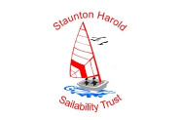
Staunton Harold Sailability Trust

“Enabling Abilities”

Fancy going sailing?
Ever wondered what sailing would be like?
Tried it already and want to have another go?

We can help! We have a range of boats and experienced sailors at a beautiful location in South Derbyshire/ Northwest Leicestershire where you can experience the wind and water in a wholly different way!

We would love to welcome you along to one of our sessions and help get you on the water!

About Us
The Staunton Harold Sailability Trust provides sailing and waterborne activities and experiences for people with any disabilities and of all ages.
We also encourage siblings and family members to take part at the same time.
Since 2016 when the Trust was officially launched, we have made great progress with the range of boats and the opportunities that we can offer our guests and we would love you to take advantage of these facilities.

We have expanded our fleet to include:
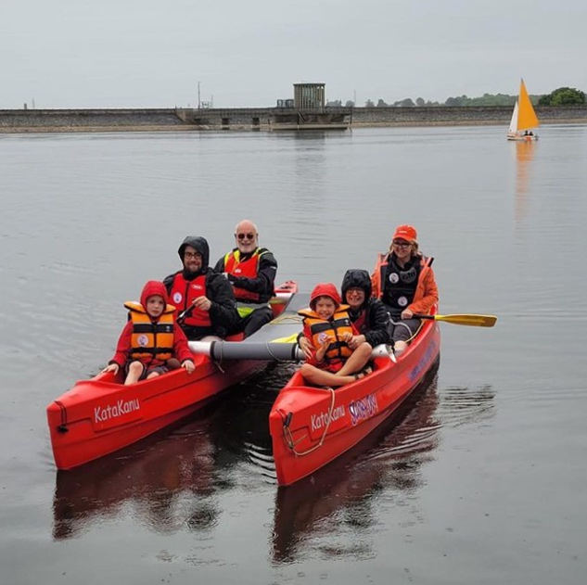
- Katakanu’s – stable, twin hulled canoes that enable groups or families to explore the glorious reservoir

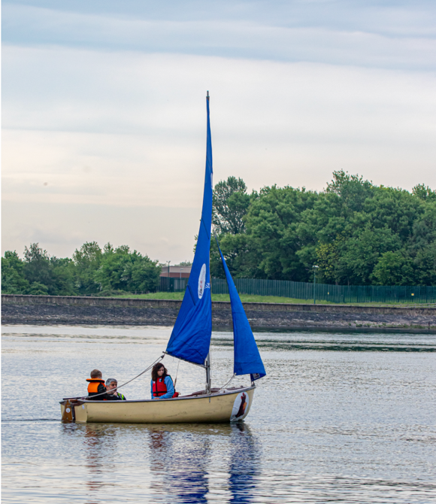

            - Coypu traditional family sailing craft that can accommodate a family or group of 4 or 5 people – depending on size – with an experienced sailor

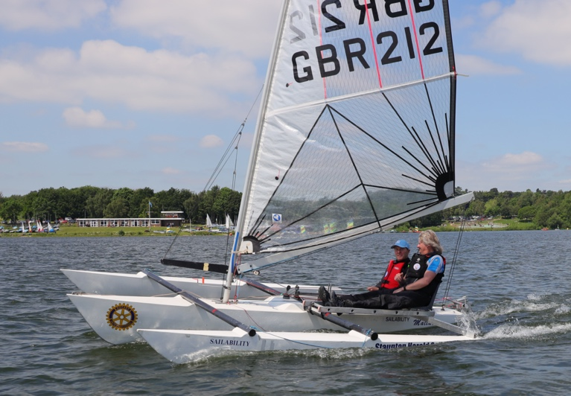

- Challenger trimarans that offer individual sailing experiences accompanied by an experienced sailor

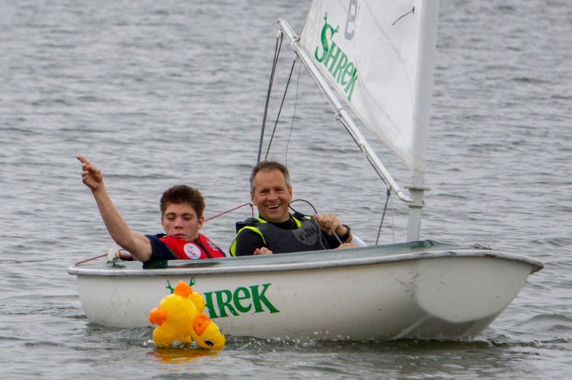

- Hansa 2 seater sailing dinghies that have simplified controls, enhanced stability and which can be sailed by our guests on their own or with an accompanying sailor

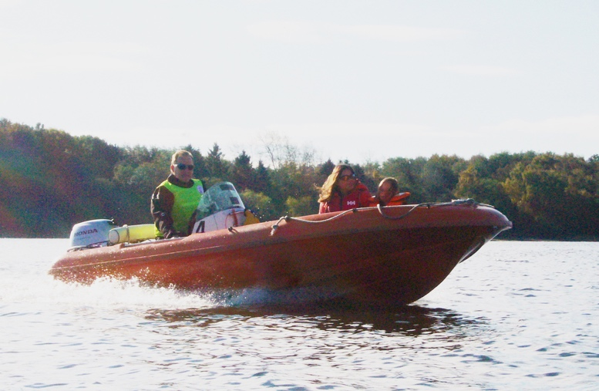
- Small outboard motor driven Juneau craft that will seat up to 4 or 5 people in addition to the pilot

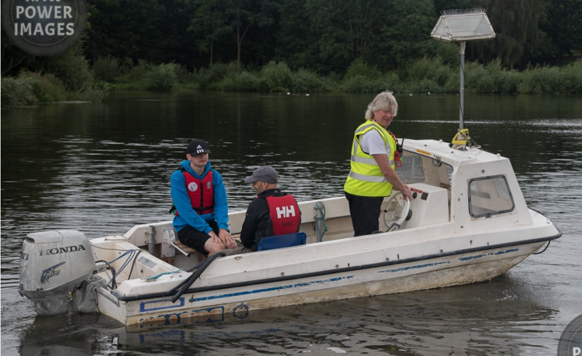

- A larger, family sized motorboat that will accommodate 6 plus the pilot

All this takes place at Staunton Harold Sailing Club situated in glorious surroundings near to Calke Abbey and have developed our on-shore base to include seating, awnings for our guests plus games and puzzles for the younger ones.

We have invested in a new, longer pontoon that makes access to and from the boats much easier and reduces the risk of not sailing when we experience drought/ low water conditions and the pontoon includes a hoist to assist with those guests who need assistance to get in and out of the boats.

We have also completed and opened a quiet zone - a nature area located away at the other end of the sailing club for our guests to chill and explore the surroundings or just watch the world go by!

We have all the safety equipment to ensure that our guests can enjoy their visit safely and with confidence and we have coverage by experienced and accredited sailors to accompany all our guests when they step on board any of our craft.

So come and join us at one or more of our monthly sessions that we run between Spring and Autumn.

Details of our 2025 programme can be found on our website www.shst.org.uk and we would be delighted to welcome you at one or more of our sessions in the coming year.

